**Assignment 23.2:**

Delayed_Flights.CSV Dataset:

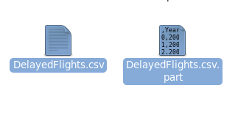

**Problem Statement1:**

Find out the top 5 most visited destinations:

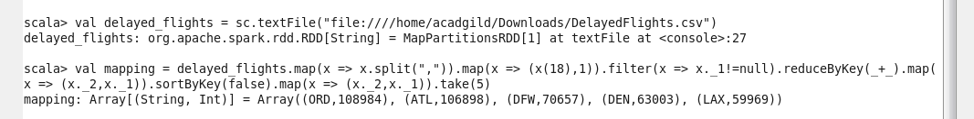

**Problem Statement2:**

Which month has seen the most number of cancellations due to bad weather?

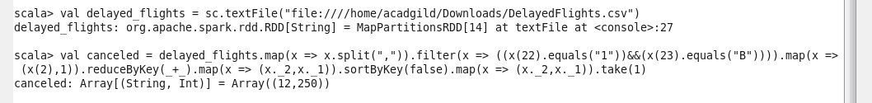

**Problem Statement3:**

Top ten origins with the highest AVG departure delay:



**Problem Statement4:**

Which route (origin and destination) has seen the maximum diversion?

